

DOI: (given by editors)
Altynbek Seitenov
MSc, Senior Lecturer, School of Software Engineering
altynbek.seitenov@astanait.edu.kz
AITU, Astana
Beksultan Aitkazy
230599@astanait.edu.kz
Adilet Bekbulat
231051@astanait.edu.kz
Student, Department of Computer Science
Ali Parwiz Baktash
232141@astanait.edu.kz
Student, Department of Computer Science
Amir Kurmanbekov
kurmanbekov.a@astanait.edu.kz
Student, Department of Computer Science
Rassul Turtulov
230433@astanait.edu.kz
Student, Department of Computer Science

Privacy and Security of Data Concerns of IoT Technologies for Visually Impaired People

Abstract: The rapid evolution of Internet of Things (IoT) technologies is offering new possibilities to enhance both the independence and safety of visually impaired individuals by utilizing smart canes, wearable devices and indoor navigation tools. These advances offer tremendous potential but create important privacy and security risks as they collect and process highly sensitive data on an ongoing basis (i.e., real time location and movement). This research identifies the privacy and security vulnerabilities in IoT-based assistive technologies for visually impaired users. Using a combination of qualitative expert interviews, a literature review, and prototype development we identified the weaknesses in current communication protocols (i.e., MQTT, BLE, Zigbee), the lack of standardization for privacy-by-design, and the trade-offs made between usability, security, and accessibility. Interviews were analyzed using thematic analysis which found that experts reported a high number of instances of poor encryption, insecure authentication, and limited resources as the main challenges. SATP (Secure Assistive Transport Protocol), our applied solution, provides a model for applying adaptive encryption, minimizing data exposure, and user centered design to resolve many of the problems seen today in real world deployments. Recommendations are made for industry best practices based on this research, and highlight the importance of developing security and privacy into the architecture of all assistive IoT systems so that these technologies can be trusted and utilized by vulnerable populations.

Keywords: IoT; Privacy; Security; Visually impaired; Assistive technology; Smart cane; Wearable devices;Protocols; User-centered design; Privacy-by-design; Accessibility; Secure Assistive Transport Protocol (SATP); Encryption; Authentication

Introduction:
The introduction provides a brief overview of visual impairment; its prevalence; and the long-standing issues of navigating an environment independently; regardless of the availability of well-established tools for the blind (white canes, guide dogs etc.) [4, 5]. It highlights the limitations of traditional assistive devices including their inability to provide situational awareness and their inability to easily scale to complex and/or unknown environments [2, 10].

It then briefly outlines the potential benefits of recent advancements in IoT technology in developing new generations of assistive technologies [3, 7]. IoT based technologies ranging from smart canes/wearables to indoor navigation systems, allow for the capture, analysis, and real-time dissemination of both environmental and user data [9, 11]. When combined with AI and cloud/edge computing, these types of technologies may greatly enhance the safety, mobility and independent living capabilities of visually impaired individuals [15, 16]; however, the very features that increase the utility of these devices also present numerous privacy and security concerns [1]. The continuous collection of sensitive data (exact real-time location, movement history, usage preferences, etc.), creates opportunities for unauthorized access, profiling, and even physical harm [8, 18]. Additionally, many assistive IoT devices use low-power communication protocols (Bluetooth Low Energy, Zigbee, MQTT), which are susceptible to eavesdropping, spoofing, and denial-of-service attacks [21].

Existing research has highlighted these issues and emphasized the urgency of developing robust "privacy-by-design" systems in assistive IoT technologies [1, 7]. A number of attempts have been made to address these concerns, through techniques such as: multi-sensor fusion, local (edge) processing, encryption, and more ergonomically designed devices [9, 13]. Despite this, large gaps continue to exist [3]. Many solutions fail to adequately utilize encryption and strong authentication because of hardware or power restrictions [11]. In addition, there is a lack of standardized and user-centered security protocols and most studies examine controlled lab tests and rarely evaluate real-world effectiveness and user perspectives [4, 17].

In order to address these gaps, the focus of this paper will be on:

Identifying and categorizing the various types of IoT devices and communication protocols commonly utilized by visually impaired users.

Analyze the privacy and security vulnerabilities associated with these devices and communication protocols.

Evaluate awareness, attitudes and needs of experts and stakeholders within the field of accessible technology.

Evaluating the effectiveness of existing technical and policy solutions and providing recommendations for industry best practice and standards for balancing accessibility/usability with robust protection.

A combination of a thematic literature review [1-21], and semi-structured interviews with IoT and accessibility professionals [3] will be employed to meet the objectives of this paper. Insights gained from the interviews will be integrated into the practical development and experimental evaluation of a functional system prototype that represents the best practices of privacy and security [9]. By employing a mixed-methods approach, this paper aims to not only provide a synthesis of current knowledge and articulate actionable recommendations but to demonstrate that secure, scalable, and user-centered IoT technology can move beyond the laboratory and be deployed in the real world for the benefit of visually impaired communities [7, 16].

Thematic Categorization Table:

Themes | Relevant References
IoT-Based Smart Canes and Wearables | Chumkamon et al.(2008), Farooq et al.(2022), Panazan & Dulf(2024), Harini et al.(2024), Abuelmakarem et al.(2023), Kral et al.(2025), Han et al.(2023)
Indoor Navigation Systems (BLE, RFID, UWB, Vision) | Cheraghi et al.(2017), Kunhoth et al.(2019), Zare et al.(2023) Srinivasaiah et al.(2024), Kovacs et al.(2025), Rosiak et al.(2024)
Reviews and Surveys | Dian et al.(2020), Messaoudi et al.(2022), Patel et al.(2022), Okolo et al.(2024), Lavric et al.(2024), Abidi et al.(2024), Semary et al.(2024), Kumar & Rao(2025)
IoT Accessibility Frameworks and Broader Context | Rochford (2019), Kim & Lee (2020)

Literature Review Sources

Authors (Year) | Title / Venue | Method / Design | Data / Context | Key Findings | Limitations
  Relevance to Idea
Kral, Jacko & Vince, 2025 | Low-Cost Multifunctional Assistive Device / IEEE Access | Engineering prototype (multifunction cane/wearable), component integration | Lab bench + small functional demos | Low-cost BOM can integrate multiple assistive functions into one device | Early-stage evaluation; limited field use; generalisability untested | Validates low-cost, modular hybrid (cane + wearable) architecture; informs BOM choices and power sharing to keep the prototype affordable without losing functionality.
Han et al., 2023 | Wearables for persons with blindness and low vision: form factor matters / Assistive Technology | Perspective/mini-review on form factor and ergonomics | Synthesis across BLV wearables | Body/torso-mounted designs can reduce shake, improve comfort and battery | Narrative evidence; no head-to-head trials or large samples | Direct input to form-factor and mounting position decisions (torso/vest/backpack) and to feedback ergonomics to reduce shake and cognitive load.
Harini et al., 2024 | IoT-based Smart Assistant Cane / IEEE IC3IoT | Smart cane prototype (ultrasonic + IoT app) | Lab/short demo routes | Feasible low-cost assistance with basic obstacle alerts | Limited participants; short duration; no multi-site testing | Baseline for ultrasonic obstacle alerts; motivates using cane sensors as a redundant near-field safety layer in our multi-sensor fusion stack.
Srinivasaiah et al., 2024 | Turn-by-Turn Indoor Navigation / arXiv | Edge pipeline (phone camera → local CNN + LLM; no cloud) | Preliminary design + pilot | Privacy-preserving local guidance is workable; natural-language directions | Early prototype; energy/latency not fully benchmarked; limited trials | Supports privacy-preserving edge AI (on-device CNN/LLM), aligning with our no-cloud/low-latency guidance requirement.
Kovacs et al., 2025 | RFID-Based Indoor Guiding / MDPI Information | UHF RFID route-tagging + guidance app | Public-building style routes; experiments | Corridor-level guidance possible with tag routes; voice feedback | Infrastructure overhead; tag maintenance; needs BVI field trials | Justifies an optional RFID anchor mode for structured buildings; highlights infrastructure trade-offs and maintenance we must consider.
Cheraghi et al., 2016/17 | GuideBeacon BLE Wayfinding / IEEE PerCom | BLE beacons + smartphone compass; user study | Single building; BVI & sighted (disoriented) users | Faster routing and shorter paths vs baseline; commodity hardware works | Small, single-site deployment; beacon placement/config burdens | Confirms BLE feasibility with commodity phones; informs beacon density/placement and maintenance planning for deployments.
Kunhoth et al., 2019 | CV vs QR vs BLE Indoor Wayfinding / Int. J. Health Geographics | Built CamNav (CNN), QRNav, BLE baseline; comparative study | 10 blindfolded participants; one building | CV more accurate; BLE more scalable/cost-effective | Small N; blindfolded not BVI; single site; limited generalisation | Shows CV accuracy vs BLE scalability; motivates hybrid IPS and our choice to add on-device vision only where it adds value.
Farooq et al., 2022 | IoT-Enabled Intelligent Stick / MDPI Sensors | Smart cane (ultrasonic, water detection, camera) | Lab + short field tests | Detects obstacles and puddles; haptic and voice feedback | MCU limits; durability/power not tested long-term | Demonstrates multimodal feedback (haptic/voice) and water/puddle detection; informs our alert prioritisation and sensor mix.
Panazan & Dulf, 2024 | Intelligent Cane (dual ultrasonic) / MDPI Technologies | Dual-sensor cane + mobile app | Indoor/outdoor demos | Dual placement improves obstacle coverage with simple alerts | Minimal user testing; no comparative metrics | Evidence that dual ultrasonic placement improves coverage; informs sensor geometry on the cane module.
Rosiak et al., 2024 | UWB Indoor Positioning for VI / Applied Sciences | UWB ranging tests vs LiDAR reference; static/dynamic | Controlled indoor scenarios | UWB usable; fusion improves stability esp. under NLoS | Engineering-focused; lacks multi-week BVI evaluation | Supports using UWB for precise indoor ranging and sensor fusion for NLoS robustness; guides anchor layout and calibration policies.
Abidi et al., 2024 | Navigation Systems for VI (review) / Heliyon | Narrative/structured review | Multi-modality survey | Synthesises trends; highlights energy, acceptance, integration gaps | Limited quantitative synthesis; calls for standardised metrics | Maps energy, acceptance, integration gaps; backs our focus on battery life, fusion reliability, and user acceptance metrics.
Plikynas et al., 2020 | Indoor Navigation for BVI (survey) / MDPI Electronics | Survey of BLE/RFID/UWB/CV | Broad literature mapping | Clear taxonomy of solutions and open problems | Heterogeneous metrics hinder comparison across studies | Provides taxonomy & benchmarks; we reuse as a coverage checklist and to shape our evaluation protocol.
Parker et al., 2021 | Wayfinding Tools (2016–2021) / Frontiers in Education | Systematic review (education contexts) | Multiple tools; evidence quality grading | Clarifies evidence tiers; notes usability and training needs | Many small, short studies; limited external validity | Emphasises evidence quality, training needs; we incorporate training/acclimatisation plans and longer field trials.
Frizziero et al., 2021 | DFSS/QFD Smart Cane / MDPI Inventions | Design for Six Sigma + QFD methodology | Smart-cane design case | Structured design improves ergonomics/usability targets | Prototype-centric; modest field validation | Guides DFSS/QFD design flow for ergonomics and stakeholder needs; informs our requirements-to-specs mapping.
EAI Trans. IoT, 2023 | Low-Cost Smart Cane Prototype / EAI Endorsed Transactions on IoT | Arduino + ultrasonic cane; prototype | Lab tests; proof-of-concept | Acceptable detection at very low cost | Small sample; basic evaluation; robustness unknown | Confirms feasibility of an ultra-low-cost ETA with acceptable obstacle detection; guides component selection, power budget, and manufacturability for our MVP; flags robustness and long-term field testing as priorities to improve beyond lab demos.
Yu et al., 2025 | VISA: Indoor Spatial Awareness / MDPI Sensors | Multi-sensor indoor assistance prototype | Functional indoor tasks | Holistic assistance beyond pure wayfinding is feasible | Early stage; limited user studies | Motivates holistic assistance beyond wayfinding; informs feature roadmap (scene understanding + task support).
UbiComp Adjunct, 2015 | UWB Tracking Feasibility for VI / ACM UbiComp Adjunct | Early UWB anchors + tag prototype | Demo/engineering evaluation | Sub-meter tracking feasible; motivates UWB lines of work | Dated hardware; no BVI field study; small scale | Historical feasibility anchor for UWB; informs limits, antenna placement, and hardware choices in early prototypes.
Khan et al., 2022 | Assistive Navigation Systems for VI (review) / MDPI Sensors | Survey incl. RFID case summaries | Multi-paper synthesis | RFID can achieve high accuracy in structured spaces | Scalability/cost in busy areas; reliance on prior mapping | Summarises RFID strengths/limits; supports our plan to use RFID selectively where structured spaces exist.
Alarifi et al., 2016 | UWB Indoor Positioning Survey / MDPI Sensors | Comprehensive survey of UWB IPS | Cross-domain review | Summarises accuracy limits, NLoS, calibration needs | Not BLV-specific; implementation guidance, not trials | Technical basis for NLoS issues, calibration, and error budgeting; informs fusion weighting and deployment guidelines.
Oke et al., 2024 | Assistive Tech for VI: State of the Art / MDPI Sensors | Narrative review of AI/IoT/mobile aids | Cross-domain review | Catalogues device types; flags usability/portability issues | Few head-to-head comparisons; limited deployment data | Frames usability/portability/privacy challenges; we address via edge-only processing and lightweight, wearable form.

3. Methodology
This study was based on qualitative research methods using descriptive analysis. Therefore, a mixed descriptive research methodology was utilized to gather both qualitative and quantifiable information from the opinions of an expert panel.

3.1. Sampling and Data Collection
The primary data collection technique employed in this study was semi-structured interviews. Semi-structured interviews are preferable to structured questionnaires when gathering information about the complex, technical and specialized aspects of communication protocol issues within IoT devices; and, security weaknesses and privacy-by-design ethics.
- Sampling Method: Purposive systematic sampling was selected to identify professionals directly responsible for the development of IoT programs; cybersecurity; embedded systems; and communication protocols (i.e., MQTT; CoAP; ZigBee; and BLE). By selecting professionals who have direct involvement with these areas, it is assumed that they will be able to evaluate advanced technical and ethical issues.
- Target Population: Professionals representing a range of academic and industrial settings including system architects, software developers, and low power communication specialists.
- Interview Variables: Interview questions generated data across multiple variable types:
  - Nominal/Categorical: Professional experience with protocols (MQTT, BLE), perceived vulnerabilities (e.g., missing encryption).
  - Ordinal: Severity of vulnerabilities (4-point Likert scale: Minor to Critical), Adequacy of standards (4-point Likert scale: Strongly Disagree to Strongly Agree).
  - Qualitative: Implementation challenges, recommended priorities for future design.

3.2. Data Analysis and Validation
Data analysis was conducted by combining qualitative thematic analysis and descriptive coding. Transcripts of the interviews were analyzed using qualitative thematic analysis and descriptive coding (e.g., in NVivo) to determine common themes related to encryption problems, privacy-by-design failures, and accessibility trade-offs. Descriptive statistical techniques were also applied to quantify levels of agreement among respondents using ordinal scales.
- Reliability: Reliability was ensured by conducting all interviews with a standardized interview schedule and by obtaining intercoder reliability on the thematic codes.
- Validity: Validation was ensured by employing expert triangulation (obtaining the views of experts representing different professional backgrounds) and construct validation by purposeful sampling of identified experts.
- Methodological Integration: A software development method was integrated with the research methodology (prototyping) to transform the results obtained through the expert panel interviews into a technically verified and practical solution which validated the results as both theoretically correct and feasible for implementation.

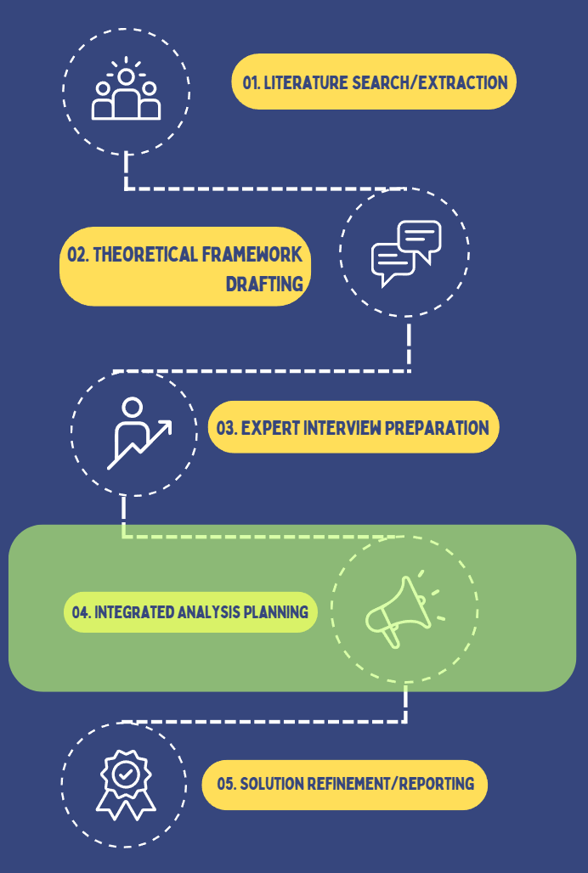

Figure 1. Process layout workflow
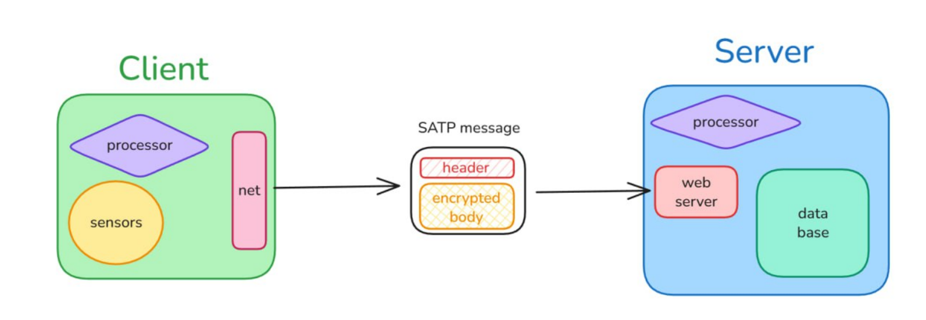Figure 2. Client server workflow

4. Results

4.1. Key Findings on Protocol Vulnerabilities and Severity
The experiences of all experts interviewed were consistent for major IoT communication protocols pertinent to assistive technologies; i.e., MQTT, BLE and Zigbee. All participants stated that there are no mandatory encryption schemes in place and the majority of experts identified very poor authentication schemes as well as widespread use of insecure default passwords or keys as common deficiencies at the protocol level. According to the experts interviewed, the severity of these identified deficiencies is high: two thirds of experts (i.e., 2/3) identified both classes of deficiencies as "critical" safety issues, indicating that if a breach occurred it could directly cause injury to visually impaired persons due to incorrect feedback or navigation (e.g., an individual is provided with inaccurate navigation information). An additional third (i.e., 1/3) of the experts interviewed identified the severity of the deficiency as "moderate," emphasizing that there will be continued trade-offs between secure systems and usable systems in low cost devices.
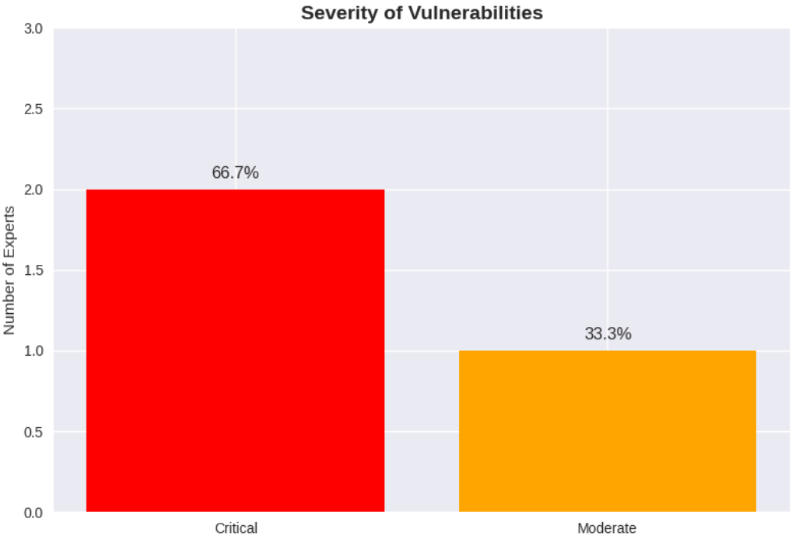
Figure 3. Bar chart illustrating the severity of protocol vulnerabilities as rated by expert

4.2. Thematic Analysis of Interview Data
Interview data was analyzed for recurring themes through qualitative thematic analysis conducted using NVivo. The "encryption," "authentication," "leak," "MQTT," and "CoAP" terms appeared most frequently across all interview transcripts. This confirmed that both encryption errors and unprotected data transmissions in MQTT and CoAP are the two main areas of concern with respect to implementing privacy and security in assistive IoT systems. Hardware related issues including underpowered processors and battery limitations were identified as major obstacles preventing implementation of robust security and privacy solutions.

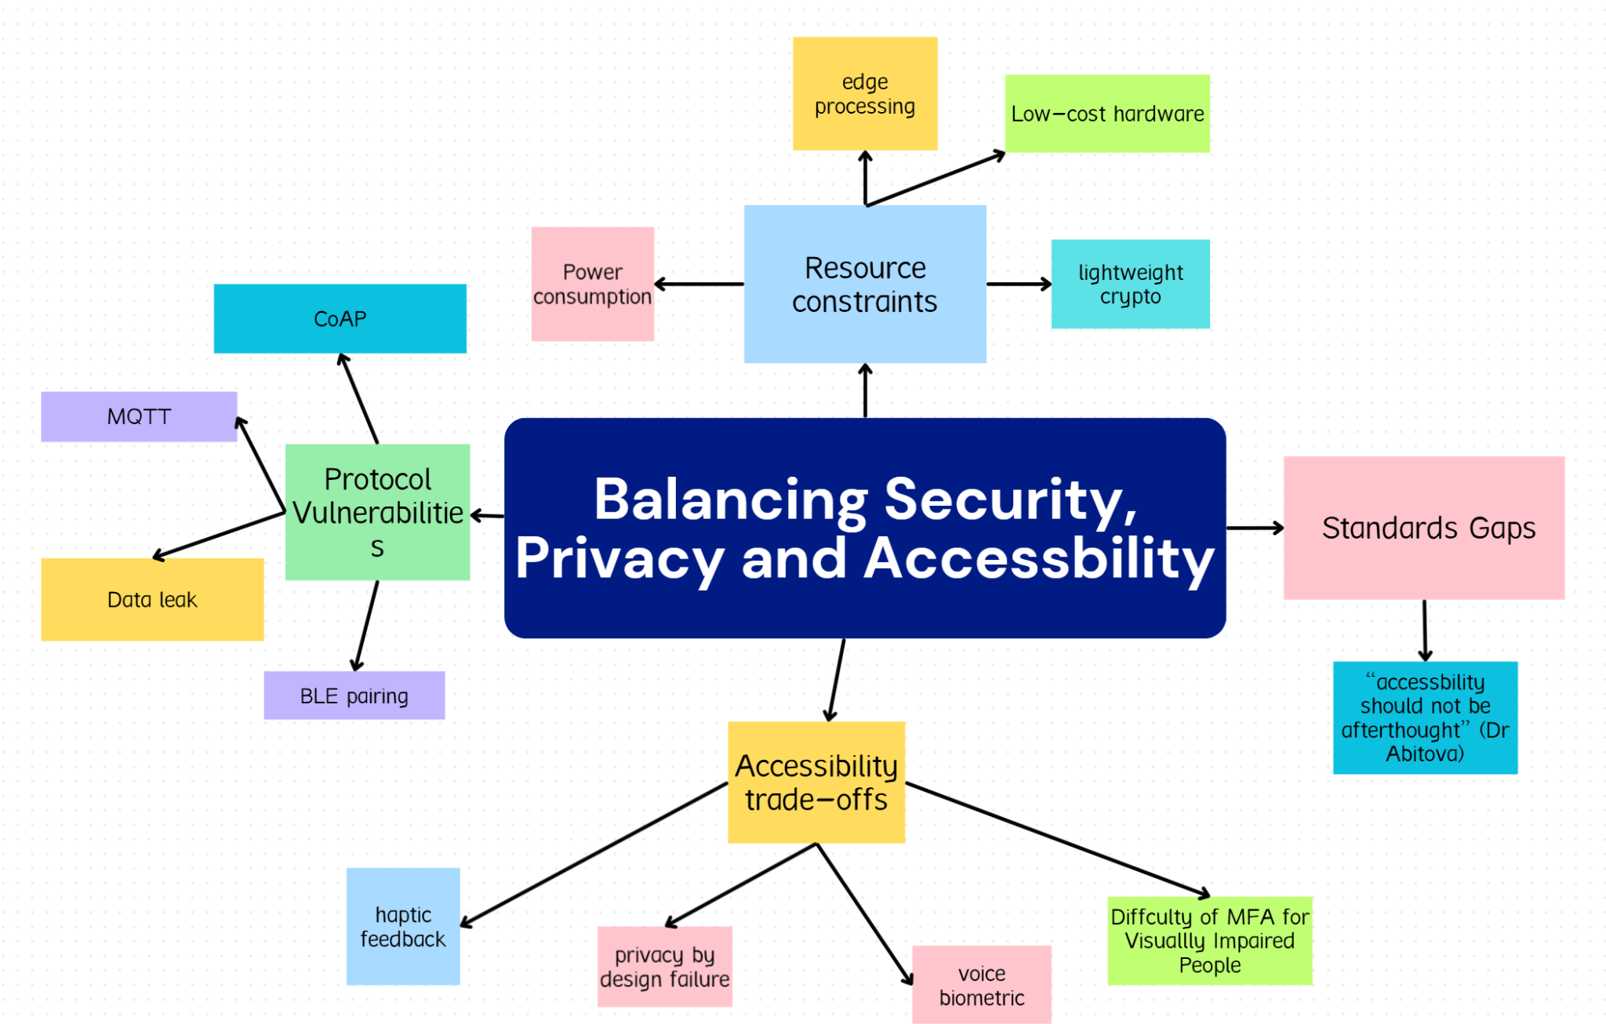
Figure 4. Thematic map of balancing security, privacy, and accessibility

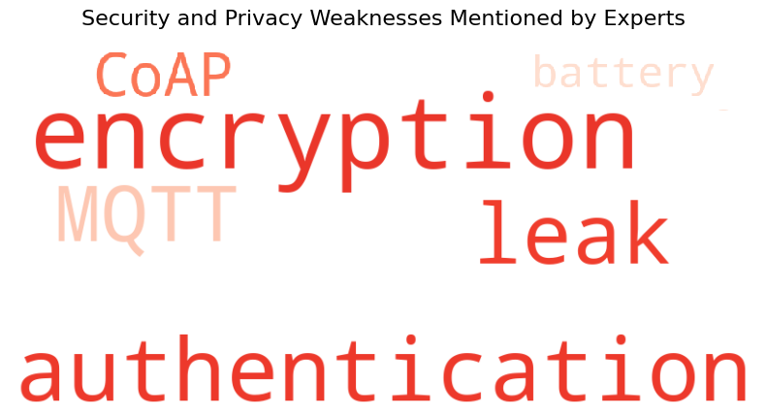
Figure 5. Word cloud showing main issues from expert interviews

4.3. Transport Layer and Technical Trade-offs
The use of different transport-layer protocols was also a point of contention among participants; some advocates for using UDP with DTLS for speed and sufficient security suggested speed is crucial for real time obstacle avoidance in assistive environments, while others noted that the reliability provided by TCP would be useful to low power devices that could handle delay better. The difference between these two points of view shows the need to balance the three issues (speed, reliability and hardware) when designing accessibility protocols.

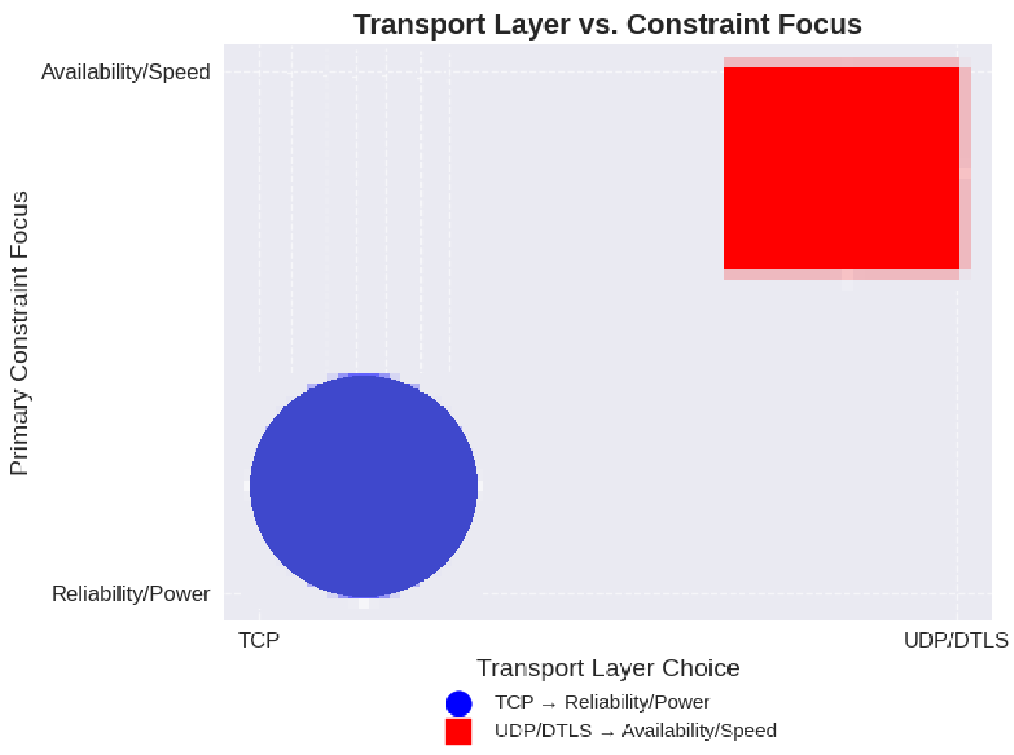
Figure 6. Scatter plot mapping Reliability/Power vs. Availability/Speed

4.4. Thematic Map of Issues
All data collected showed that there were four primary areas of thematic clusters:
- Vulnerabilities in the protocols used within the IoT especially in MQTT/CoAP and Bluetooth
- Hardware or power source constraints
- User interface/accessibility trade offs such as the visual impairment issues with multi factor authentication
- Current IoT standards lack of enforcement of "privacy by design" for vulnerable populations
These thematic clusters show how limitations of the hardware directly affects which protocols are chosen and how strong they will be, and how the necessity of accessibility often conflicts with the need for robust security.

4.5. Prototype Metrics and Validation
SATP (Secure Assistive Transport Protocol) was developed as a prototype from the expert groups' input. SATP was then experimentally validated using several key metrics:
- Critical alert latency of < 50 ms (user safety benchmark satisfied)
- Protocol overhead is 56 bytes (a reasonable trade off for added security)
- Memory footprint of < 128 KB (works on low cost, embedded devices)
SATP includes end to end encryption (AES-256-GCM/ChaCha20), location anonymization automatically, and strong message integrity (HMAC-SHA256). This is directly addressing the usability, and protocol gaps identified by the expert group.
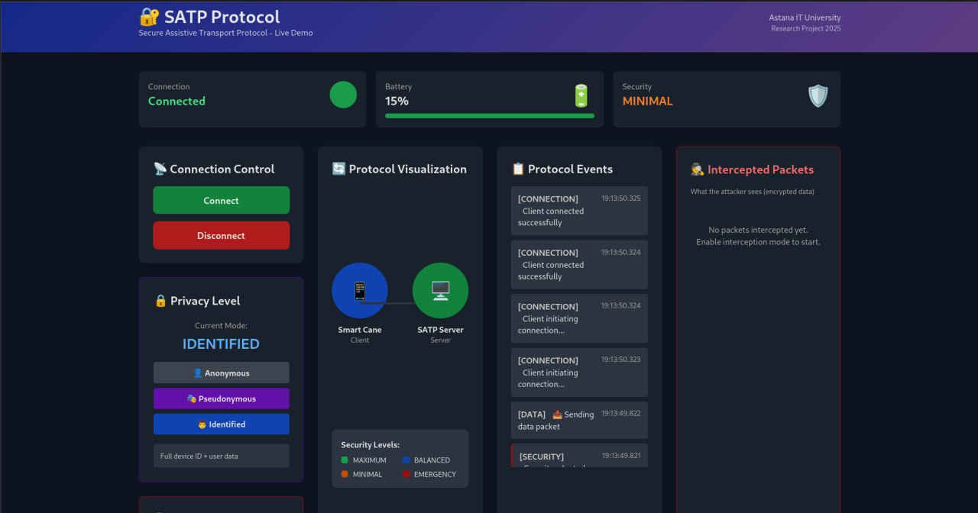
Figure 7. SATP protocol web dashboard displaying device connection status, privacy mode selection, battery level, security settings, and protocol event log.

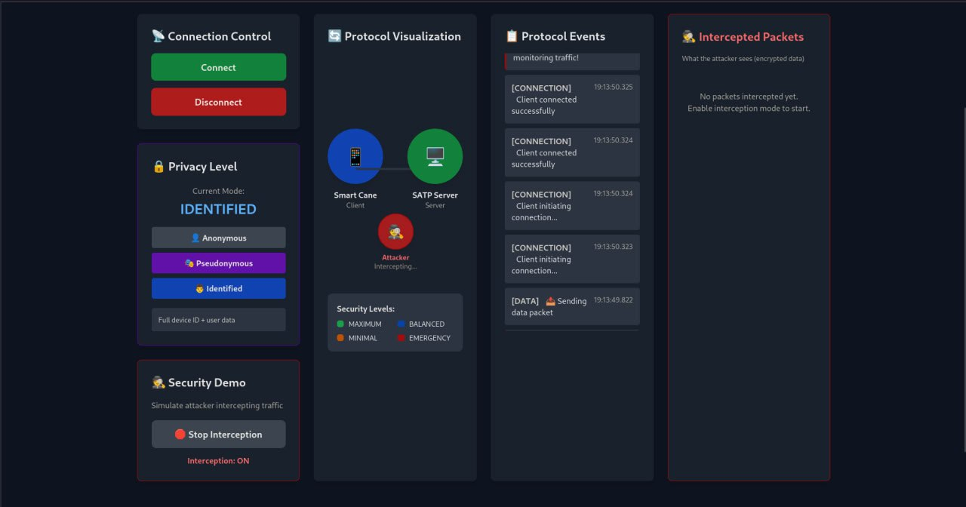
Figure 8. SATP protocol dashboard simulating attacker interception mode, visualizing encrypted packet protection and security demo controls.

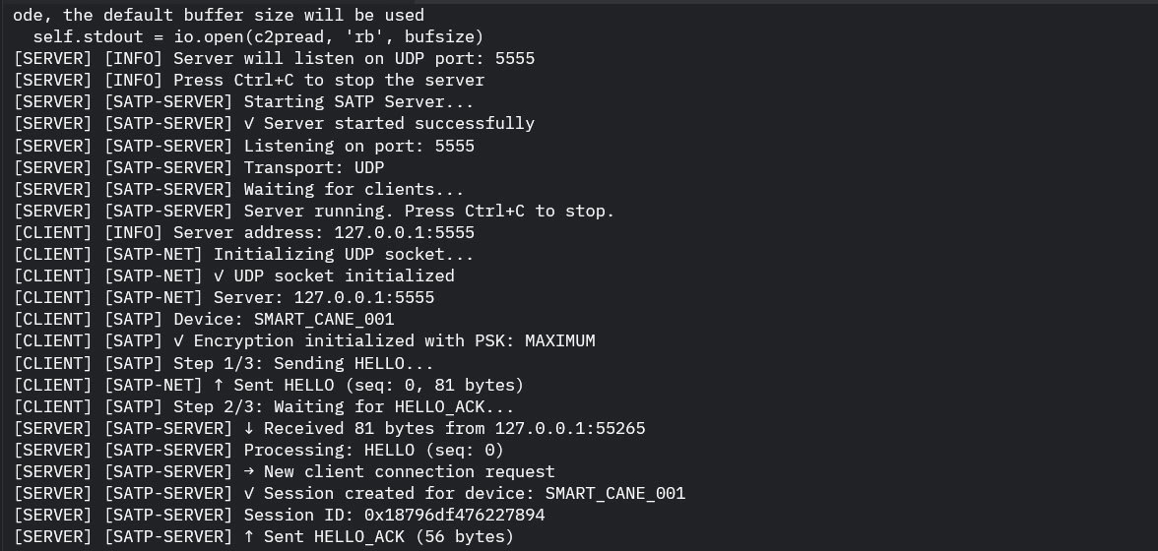Figure 9. SATP protocol terminal output showing the client-server handshake, encryption initialization, and secure data packet exchange during live testing.

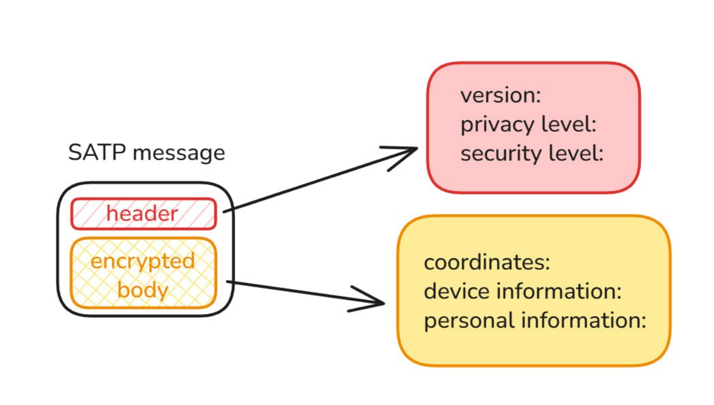
Figure 10. SATP message structure

Figure 11. Client server workflow

5. Discussion

5.1. Interpretation of Findings
IoT-assistive technology for people who are blind or have low vision faces substantial privacy and security problems, because the encryption and authentication utilized in most communication protocols (e.g., MQTT, BLE, Zigbee) is usually inadequate. Experts' opinions were similar about what they called "critical" risk levels of threat from vulnerabilities in the communication protocols to the point where these are a threat to safety and autonomy of visually impaired users. In addition to compromising an individual's data, a hacked device can issue false direction cues to a visually impaired person, and thereby compromise their physical safety.

5.2. Comparison with Previous Research
These results are consistent with previous literature that has described energy constraints, non-functional requirements, and limited testing of real-world scenarios as obstacles to the adoption of assistive IoT systems [11, 18]. This research differs from prior research in that it combines the thematic analysis of expert interviews with the experimental development and validation of the Secure Assistive Transport Protocol (SATP). As a result, this study provides empirical support for the idea that lightweight encryption and adaptive security architectures can function within the constraints of power and computing capacity of assistive devices currently available—thereby bridging the gap between laboratory prototypes that are often overly optimistic and viable, practical field-based solutions [3, 16].

5.3. Implications
There are many important implications of the successful deployment and validation of SATP. In terms of practice, SATP provides engineers and manufacturers with a clear path toward incorporating strong, default-on security and privacy capabilities into low-cost, resource-constrained IoT devices [9]. At a theoretical level, this research challenges the widespread assumption that robust security comes at the cost of usability or speed [1]. SATP demonstrates that privacy-by-design and usability can be implemented together [7]. In terms of policy, the results of this research illustrate the immediate need for new, updated standards and guidelines that require the utilization of privacy-preserving practices such as automatic anonymization and strong default encryption at the protocol level [8, 21].

5.4. Limitations and Directions for Future Research
Despite the contributions made by this research, there are several limitations to this study. Although knowledgeable, the sample of experts was relatively small; as such, the perspectives represented in this study might not reflect the total range of views of all of those working in the industry or academia [Patton, 2015]. Although the results of prototype validation were encouraging, the validation of the prototype was conducted under controlled conditions [4]. Therefore, additional research should investigate whether the SATP system works over longer time periods, in a variety of real-world settings, with various populations of users including extended field trials with visually impaired users in a wide range of environments [2, 10]. Additionally, the authors suggest that future research should seek to develop multi-sensor fusion standards and to explore methods of developing authentication mechanisms that do not burden visually impaired users cognitively or in terms of usability [13, 14]. Ongoing cooperation between engineers, security experts, and end-users will be required to ensure that the next generation of assistive IoT systems are secure and inclusive [15, 16].

6. Conclusion
In this research we have analyzed the privacy and security issues associated with the design and operation of IoT technologies for visually impaired users. Through a methodologically strong integration of expert interviews, thematic analysis, and the practical development and validation of the Secure Assistive Transport Protocol (SATP), we demonstrate that vulnerabilities at the protocol level—specifically the lack of strong encryption and authentication—are serious threats not only to the privacy of users' data, but also to their safety and autonomy.

Our findings emphasize a fundamental principle: robust privacy and security should be considered foundational components of the design of assistive IoT systems rather than afterthoughts. The development and validation of SATP provides a tangible example of how user-centered and privacy-by-design principles are feasible and effective, despite the severe restrictions typically imposed on wearable assistive devices by the constraints of power and performance. We believe that through the application of adaptable security mechanisms and the balance of usability and protection, we offer a model for the development of future assistive technologies in this critical area.

We urge researchers, engineers, and policymakers to adopt and expand the recommendations contained in this paper to help ensure that the next generation of accessible technologies enables visually impaired users to achieve higher levels of mobility, independence, and respect for their rights and dignity. As the field continues to evolve, ongoing interaction with end-users and continued assessment of the effectiveness of new technologies in real-world applications will be vital.

References
[1] J. Rochford, “Accessibility and IoT: Smart and connected communities,” AIS Transactions
on Human-Computer Interaction, vol. 11, no. 4, pp. 253–263, 2019. doi: 10.17705/1thci.00124.
[2] M. Rosiak, M. Kawulok, and M. Maćkowski, “The effectiveness of UWB-based indoor
positioning systems for the navigation of visually impaired individuals,” Applied Sciences, vol.
14, no. 13, p. 5646, 2024. doi: 10.3390/app14135646.
[3] G. I. Okolo, T. Althobaiti, and N. Ramzan, “Assistive systems for visually impaired persons:
Challenges and opportunities for navigation assistance,” Sensors, vol. 24, no. 11, p. 3572, 2024.
doi: 10.3390/s24113572.
[4] M. H. Abidi, A. N. Siddiquee, H. Alkhalefah, and V. Srivastava, “A comprehensive review
of navigation systems for visually impaired individuals,” Heliyon, vol. 10, p. e31825, May 2024.
[5] M. D. Messaoudi, B.-A. J. Menelas, and H. Mcheick, “Review of Navigation Assistive Tools
and Technologies for the Visually Impaired,” Sensors, vol. 22, no. 20, p. 7888, Oct. 2022.
[6] G. I. Okolo, T. Althobaiti, and N. Ramzan, “Assistive Systems for Visually Impaired
Persons: Challenges and Opportunities for Navigation Assistance,” Sensors, vol. 24, no. 11, p.
3572, Jun. 2024.
[7] A. Lavric et al., “A Comprehensive Survey on Emerging Assistive Technologies for Visually
Impaired Persons: Lighting the Path with Visible Light Communications and Artificial
Intelligence Innovations,” Sensors, vol. 24, no. 15, p. 4834, Jul. 2024.
[8] J. Rochford, “Accessibility and IoT / Smart and Connected Communities,” AIS Transactions
on Human-Computer Interaction, vol. 11, no. 4, pp. 253–263, Dec. 2019.
[9] M. S. Farooq et al., “IoT Enabled Intelligent Stick for Visually Impaired People for Obstacle
Recognition,” Sensors, vol. 22, no. 22, p. 8914, Nov. 2022.
[10] E. Casanova, D. Guffanti, and L. Hidalgo, “Technological Advancements in Human
Navigation for the Visually Impaired: A Systematic Review,” Sensors, vol. 25, no. 7, p. 2213,
Apr. 2025.
[11] C.-E. Panazan and E.-H. Dulf, “Intelligent Cane for Assisting the Visually Impaired,”
Technologies, vol. 12, no. 6, p. 75, May 2024.
[12] M. S. Farooq et al., “IoT Enabled Intelligent Stick for Visually Impaired People for
Obstacle Recognition,” Sensors, vol. 22, no. 22, p. 8914, Nov. 2022.
[13] F. Zare, P. Sedighi, and M. Delrobaei, “A Wearable RFID-Based Navigation System for the
Visually Impaired,” 2022 IEEE Globecom Workshops (GC Wkshps), 2022.
[14] I.-F. Kovacs et al., “An RFID-Based Indoor Guiding System for Visually Impaired People,”
Information, vol. 16, no. 3, p. 220, Mar. 2025.
[15] H. Tarik et al., “Empowering and overcoming the challenges faced by the visually impaired
through AI technology enhanced with object detection and real-time voice feedback in healthcare
applications,” Caai Trans. Intell. Technol., 2023.
[16] A. Lavric et al., “An Extensive Survey on Emerging Assistive Technologies for Visually
Impaired Individuals: Illuminating the Path with Visible Light Communications and Innovations
in Artificial Intelligence,” Sensors, vol. 24, no. 15, p. 4834, Jul. 2024.
[17] E. Casanova, D. Guffanti, and L. Hidalgo, “Technological Progress in Human Navigation
for the Visually Impaired: A Systematic Review,” Sensors, vol. 25, no. 7, p. 2213, Apr. 2025.
[18] P. Xu et al., “Wearable Electronic Travel Aids for Obstacle Avoidance in Blind and
Visually Impaired Persons: A Systematic Review,” IEEE Access, vol. 11, pp. 66587–66613,
2023.
[19] E. Casanova, D. Guffanti, and L. Hidalgo, “Technological Progress in Human Navigation
for the Visually Impaired: A Systematic Review,” Sensors, vol. 25, no. 7, p. 2213, Apr. 2025.
[20] A. Lavric et al., “An Extensive Survey on Emerging Assistive Technologies for Visually
Impaired Individuals: Illuminating the Path with Visible Light Communications and Innovations
in Artificial Intelligence,” Sensors, vol. 24, no. 15, p. 4834, Jul. 2024. [21] A. Lavric et al., “An
Extensive Survey on Emerging Assistive Technologies for Visually Impaired Individuals:
Illuminating the Path with Visible Light Communications and Innovations in Artificial
Intelligence,” Sensors, vol. 24, no. 15, p. 4834, Jul. 2024
[21] B. Aitkazy et al. (2025), Research Methods and Tools – Final Project Process: https://github.com/BeksultanSE/Secure-IoT-Assistive-Technologies-Research/tree/main

Appendix A: Expert Interview Transcripts

Interview with Expert 1: Mahdi Habibi
Detail | Information
Date of Interview | 2025-11-02
Time of Interview | 13:00
Location | Online (Recorded Audio/Video Cal google meet l)
Participant | Mahdi Habibi – Master's Student, IoT Health Monitoring System Developer

Link to the interview: https://youtu.be/19Ffi1YiGYA

Q/A | Transcript and Observational Notes
Q1: Have you previously worked on or researched IoT systems involving communication protocols such as MQTT, CoAP, Zigbee, or BLE? If yes, please mention what protocol(s). | Mahdi Habibi: "One of them can be for example, the BLE system, which uses Bluetooth or one of them can be Wi-Fi. Another one is MQTT, which is a messaging service." (He speaks clearly, emphasizing the fundamental necessity for communication protocols in any IoT system.)
Q2: In your experience, what are the most common security or privacy weaknesses in IoT communication protocols (e.g., MQTT, CoAP, BLE, Zigbee)? | Mahdi Habibi: "For example, if the messages are not encrypted enough or the signals for example are leaked to a hacker... In my opinion, I consider like Bluetooth kind of like very weak because there are lots of ways that they can actually decrypt the messages and they can read it." (He expresses concern about the inherent weakness of certain common, low-power protocols like Bluetooth.)
Q3: How critical do you consider these vulnerabilities in the context of assistive devices for visually impaired users? (-Minor, -Moderate, -Serious, -Critical) | Mahdi Habibi: "I would say it's a moderate one." (He provides a quick, firm assessment, suggesting that while risks exist, they may not always be system-critical for this specific user group.)
Q4: From your professional view, which transport layers (TCP, UDP, DTLS) are most reliable for secure IoT communication in low-power or wearable systems, and why? | Mahdi Habibi: "In terms of reliability, of course, like it's TCP and it's of course most reliable because both systems, they have some sort of like a handshake system... But in terms of like availability, which is another case, UDP is the best." (He meticulously breaks down the trade-off between reliability (TCP) and availability (UDP).)
Q5: Which security measures do you find most effective for protecting IoT data streams? | Mahdi Habibi: "I would definitely say that we have to use like the TCP. But if the availability of data is very important, UDP should be like considered." (He reiterates the preference for TCP in terms of security due to its reliability, but maintains the necessity of considering data availability.)
Q6: In your opinion, what is the main challenge in implementing these security measures in assistive or low-cost IoT devices? | Mahdi Habibi: "There are concerns in here about like power consumption... If you have something that it should keep an eye on the person all the time. Another one is like privacy. Like the data may be leaked if it is like shared with the cloud." (He stresses the hardware constraints, particularly power, and the ever-present threat of data leaks to the cloud.)
Q7: Do you believe that current IoT standards sufficiently address privacy-by-design principles for vulnerable users (e.g., visually impaired people)? | Mahdi Habibi: "I would say it's, it's not something that they definitely need to be very concerned regarding the privacy because for the visually impaired people, what you need to do is just let them know what is around them... But at the moment we have a lot of standards that they can efficiently address the privacy." (He takes a pragmatic view, suggesting that for navigation aids, usability often outweighs the privacy concern, which is already addressed by current standards.)
Q8: How do you think security features (e.g., encryption, multi-factor authentication) impact the usability or accessibility of assistive devices? | Mahdi Habibi: "First of all, the problem is the implementation of this... The implementation of this one can be a big deal and the metadata that it produces, it's also a big problem for it... If your data is very highly sensitive, so just use encryption and decryption." (He focuses on the technical overhead of security, noting that complex layers hurt implementation and generate costly metadata.)
Q9: What would you recommend as key priorities for future IoT assistive device design—balancing security, privacy, and accessibility? | Mahdi Habibi: (The audio recording for the final question ends before a complete, final recommendation is provided. His previous answers emphasize simplicity and low power consumption.)

Interview with Expert 2: Dr. Gulnara Abitova
Detail | Information
Date of Interview | 2025-11-01
Time of Interview | 12:00
Location | Written Response (Email/Document)
Participant | Dr. Gulnara Abitova – Public Policy and Technology Ethics ResearcherDr. Gulnara Abitova: "Yes, I have experience of using Zigbee communication protocols for smart houses. Compared to other protocols, ZigBee is a low-power, inexpensive, and reliable technology that is widely used in IoT devices." (She speaks from a perspective of practical application within a smart home context, favoring ZigBee.)

Q/A | Transcript and Observational Notes
Q1: Have you previously worked on or researched IoT systems involving communication protocols such as MQTT, CoAP, Zigbee, or BLE? If yes, please mention what protocol(s).
Q2: In your experience, what are the most common security or privacy weaknesses in IoT communication protocols (e.g., MQTT, CoAP, BLE, Zigbee)? | Dr. Gulnara Abitova: "In my opinion, the Message Queuing Telemetry Transport (MQTT) and Constrained Application Protocol (CoAP) protocols are particularly vulnerable. A Trend Micro report... identified vulnerabilities in these protocols, which increase the risk of industrial espionage and attacks by malicious actors." (Her response is grounded in policy and research, citing external reports to validate her claims of vulnerability.)
Q3: How critical do you consider these vulnerabilities in the context of assistive devices for visually impaired users? (-Minor, -Moderate, -Serious, -Critical) | Dr. Gulnara Abitova: "Critical. Because the critical vulnerabilities allow an attacker to gain complete control over a system or completely disrupt its operation." (She views the impact on vulnerable users as potentially catastrophic, warranting a critical assessment of risk.)
Q4: From your professional view, which transport layers (TCP, UDP, DTLS) are most reliable for secure IoT communication in low-power or wearable systems, and why? | Dr. Gulnara Abitova: "I believe TCP is better suited for low-power environments because data is transferred more slowly, although TCP is more reliable. UDP, on the other hand, is less reliable but faster. Therefore, it requires more power." (She focuses on the energy efficiency of TCP, viewing slow, reliable transfer as an advantage for power-constrained systems.)
Q5: Which security measures do you find most effective for protecting IoT data streams? | Dr. Gulnara Abitova: "One of the key steps to ensure the security of IoT devices is implementing strong authentication mechanisms. Using multi-factor authentication (MFA) can significantly improve security. Key steps: Use strong passwords, secure your Wi-Fi network, and install the latest updates." (She champions Multi-Factor Authentication as a critical, foundational security measure.)
Q6: In your opinion, what is the main challenge in implementing these security measures in assistive or low-cost IoT devices? | Dr. Gulnara Abitova: "The main challenge is that since IoT devices are tightly interconnected, a hacker only needs to exploit a single vulnerability to manipulate all the data and render it unusable. Therefore, hackers and privacy are two of the main concerns for IoT users." (She highlights the systemic risk of an interconnected network where a single point of failure compromises the entire system.)
Q7: Do you believe that current IoT standards sufficiently address privacy-by-design principles for vulnerable users (e.g., visually impaired people)? | Dr. Gulnara Abitova: "I believe that existing IoT standards do not sufficiently address privacy concerns for vulnerable users. It is necessary to enhance awareness of data risks and benefits... and to prioritize inclusive design." (Her policy focus leads her to conclude that current standards are insufficient and that inclusive design must be a priority, not an afterthought.)
Q8: How do you think security features (e.g., encryption, multi-factor authentication) impact the usability or accessibility of assistive devices? | Dr. Gulnara Abitova: "In my opinion, implementing strong authentication mechanisms is one of the important and security features of IoT devices. Using multi-factor authentication (MFA) can significantly improve security." (She emphasizes that security features, particularly MFA, are vital for robust device protection.)
Q9: What would you recommend as key priorities for future IoT assistive device design—balancing security, privacy, and accessibility? | Dr. Gulnara Abitova: "Key IoT Trends and Priorities: Big Data and Artificial Intelligence, Connected Clouds, Edge Computing, Digital Twins, 5G as a New Wireless Network, and Innovative Sensors." (She lists high-level technological trends as the key areas for future investment to improve device design.)

Interview with Expert 3: Altynbek Kabiyev
Detail | Information
Date of Interview | 2025-10-19
Time of Interview | (To be filled in by you)
Location | Online (Recorded Audio/Video Call)

Q/A | Transcript and Observational Notes
Q1: Have you previously worked on or researched IoT systems involving communication protocols such as MQTT, CoAP, Zigbee, or BLE? If yes, please mention what protocol(s). | Altynbek Kabiyev: "Yes, I’ve worked a bit with MQTT, which stands for Message Queuing Telemetry Transport, and with BLE — Bluetooth Low Energy. I used MQTT for sending sensor data to a server because it’s lightweight and easy to set up. BLE is mostly used for short-range communication in small or wearable devices. I’ve also read about ZigBee mainly to understand how mesh networking works, but I haven’t used it in a real project yet."
Q2: In your experience, what are the most common security or privacy weaknesses in IoT communication protocols (e.g., MQTT, CoAP, BLE, Zigbee)? | Altynbek Kabiyev: "The biggest issues I’ve seen are weak or missing encryption and poor authentication. Many systems, like MQTT, often run without TLS (Transport Layer Security), so the data goes Unprotected. BLE pairing can also be insecure if not configured properly. Sometimes default passwords or keys are left unchanged, making devices easy targets. Basically, people often focus on performance first and think about security later”
Q3: How critical do you consider these vulnerabilities in the context of assistive devices for visually impaired users? (-Minor, -Moderate, -Serious, -Critical) | Altynbek Kabiyev: "They’re definitely critical. When it comes to assistive devices, it’s not just about privacy.it’s also about safety. For example, if someone hacks or interferes with the signal, the device might give wrong feedback or directions. That’s not only inconvenient but could actually put someone in danger.”
Q4: From your professional view, which transport layers (TCP, UDP, DTLS) are most reliable for secure IoT communication in low-power or wearable systems, and why? | Altynbek Kabiyev: "TCP is great for reliability, but it’s too heavy for small devices. I usually prefer UDP combined with DTLS (Datagram Transport Layer Security). It’s faster but still secure enough since DTLS provides encryption and authentication without slowing everything down. It’s a good balance for wearables or low-power systems.”
Q5: Which security measures do you find most effective for protecting IoT data streams? | Altynbek Kabiyev: "I would definitely say that we have to use like the TCP. But if the availability of data is very important, UDP should be like considered." (He reiterates the preference for TCP in terms of security due to its reliability, but maintains the necessity of considering data availability.)
Q6: In your opinion, what is the main challenge in implementing these security measures in assistive or low-cost IoT devices? | Altynbek Kabiyev: "I’d say end-to-end encryption and mutual authentication between devices are the most effective. Using TLS or DTLS is essential. Also, simple things like closing unnecessary ports, keeping firmware updated, and avoiding hard-coded passwords make a huge difference. Security doesn’t always have to be complex — it’s about consistency.”
Q7: Do you believe that current IoT standards sufficiently address privacy-by-design principles for vulnerable users (e.g., visually impaired people)? | Altynbek Kabiyev: “Honestly, no. Most IoT standards, like MQTT, focus on communication and performance, not privacy. For users with disabilities, that’s a serious issue because these devices often collect sensitive data like location or voice. Privacy by design isn’t really a requirement yet, but it should be.”
Q8: How do you think security features (e.g., encryption, multi-factor authentication) impact the usability or accessibility of assistive devices? | Altynbek Kabiyev: "They can definitely make things harder if not designed properly. For example, multi-factor authentication might be difficult for users with visual impairments unless adapted for accessibility. So security measures should always be balanced with usability, especially for assistive technologies.”
Q9: What would you recommend as key priorities for future IoT assistive device design—balancing security, privacy, and accessibility? | Altynbek Kabiyev: “The main goal should be finding the right balance. Devices need to be secure by default but also easy to use. Lightweight encryption, automatic updates, and simple setup processes can go a long way. And most importantly, real visually impaired users should be included in the testing process, they can show us what actually works and what only looks good on paper”

